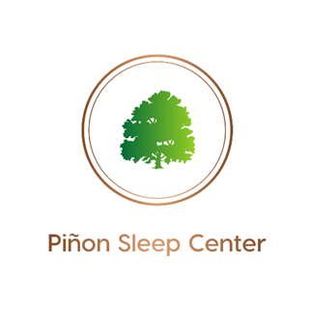
AASM ACCREDITED
904 E. 20th St. Unit C Farmington, NM 87401
Phone: 505-787-2680 l Fax: 505-787-2668
SLEEP STUDY REQUEST FORM
Patient Information:
Name: Date of birth:
Home Phone: Cell Phone: Gender: M F
Ordering Physician Information:
Requesting Physician:
Phone:
Fax : NPI:
Study Requested:
PSG (monitoring only) Split-Night PAP Titration Home Sleep Test (HST)
ASV Oxygen Titration Dental Appliance Efficacy Study MWT
MSLT (includes PSG night prior) ETCO2 monitoring (can be added to any adult study; will ALWAYS be included on pediatric studies (per AASM requirements).
Other
Diagnosis(es) (check all that apply):
OSA Restless legs Parasomnias Narcolepsy
Excessive Daytime Sleepiness Snoring Shiftwork Insomnia
Other
If you would like Piñon Sleep Healthcare to provide continued care in Sleep Medicine, follow-ups, compliance, any sleep results (sleep provider consulted) please check here
If you would prefer to go over results and order any recommended DME (PAP, etc.) for your patient (no sleep provider consultation), please check here
Please Fill Out Form In Its Entirety And Fax To (505) 787-2668

