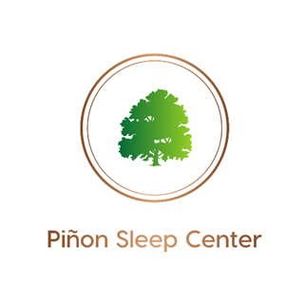
AASM ACCREDITED
904 E. 20th St. Unit C Farmington, NM 87401
Phone: 505-787-2680 l Fax: 505-787-2668
SLEEP STUDY REQUEST FORM
Patient Information:
Name: ______________________________________ Date of Birth: __________________
Home Phone: __________________ Cell Phone: ___________________ Gender: M F (circle one)

Ordering Physician Information:
Requesting Physician: _____________________________________ NPI: ____________________
Phone: ____________________ Fax: __________________________

Study Requested:
____PSG (monitoring only) ____Split Night ____PAP Titration ____HST (Home Sleep Test)
____ASV ____Oxygen Titration ____Dental Appliance Efficacy Study ____MWT
____MSLT(includes PSG night prior) ____ETCO2 monitoring (can be included with any adult study above; will ALWAYS be done on pediatric studies as required by the AASM)
____Other________________________________________________________________________
Diagnosis(es): (check all that apply)
____OSA ____Restless Legs ____Parasomnias ____Narcolepsy ____Excessive Daytime Sleepiness
____Snoring ____Shiftwork ____Insomnia ____Other ______________________________________
____ If you would like Piñon Sleep Healthcare to provide continued care in Sleep Medicine, follow-ups, compliance, any sleep results (sleep provider consulted) please check here.
____ If you would prefer to go over results and order any recommended DME (PAP, etc.) for your patient (no sleep provider consultation), please check here.
Please Fill Out Form In Its Entirety And Fax To (505) 787-2668

